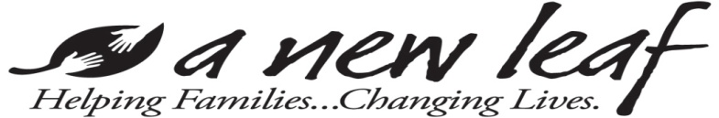

DVSTOP HOTEL MOTEL VOUCHER FORM

Voucher # DVSTOP: Date: Time:

Contact Information: (480)890-3039 Gender: M F

Head of Household (alias):

Name of Hotel/Motel:

DESCRIPTION OF SERVICE | ROOM PRICE | TOTAL PRICE
 | $ | $
CHARGE NOT TO EXCEED:  DOLLARS |  | ($ )

MERCHANT: For payment submit this voucher to:

A New Leaf
Accounts Payable
868 E. University Drive
Mesa, AZ 85203

DVSTOP

The hotel/motel in which you are staying has been provided for your use. In accepting this room, we expect you will follow all posted rules of the hotel/motel and all guidelines of this partnership program, discussed with you prior to acceptance into the program, specifically:

- Charges cannot be made to the room for any reason, including meals, liquor, room service, movie rentals, telephone calls, smoking or any other items that may be above and beyond the listed room rate.
- Children must be kept with you at all times.
- Confidentiality of hotel location and phone number must be maintained. Visitors are not allowed.
- Guests will be expected to maintain general cleanliness of the room and allow housekeeping daily access to the room.

By signing this form, you agree that you and your household will not hold A New Leaf or the providing Hotel/Motel responsible for any liability incurred on the property because of participation in this program whether that liability results from physical damage, bodily injury, or other causes.

Should any problems occur, the decision of the Hotel/Motel management will be final in all matters. If the Hotel/Motel asks you to leave, the decision will be entirely between you and the Hotel/Motel staff and your services with our program will end at that point.

________________________________ _____ _________________________________________
Signature of Head of Household Signature of Staff

